Chapter 2 Financial Market Environment

Financial Institutions & Markets

Firms that require funds from external sources can obtain them in three ways:

through a financial institution

through financial markets

through private placements

The Glass-Steagall Act was an act of Congress in 1933 that created the federal deposit insurance program and separated the activities of commercial and investment banks.

Repealed in the late 1990s.

The shadow banking system describes a group of institutions that engage in lending activities, much like traditional banks, but these institutions do not accept deposits and are therefore not subject to the same regulations as traditional banks.

Financial Markets

Financial markets are forums in which suppliers of funds and demanders of funds can transact business directly.

A private placement involves the sale of a new security directly to an investor or group of investors.

Most firms, however, raise money through a public offering of securities, which is the sale of either bonds or stocks to the general public.

The primary market is the financial market in which securities are initially issued; the only market in which the issuer is directly involved in the transaction.

IPO

Seasoned Shares

Only time issuer gets funds from investors

Secondary markets are financial markets in which pre-owned securities (those that are not new issues) are traded.

Markets

The money market is created by a financial relationship between suppliers and demanders of short-term funds.

marketable securities

among the least risky investments available.

The capital market is a market that enables suppliers and demanders of long-term funds to make transactions.

The key securities are bonds and both common and preferred stock.

Broker Markets and Dealer Markets

Broker markets are securities exchanges on which the two sides of a transaction, the buyer and seller, are brought together to trade securities.

Trading takes place on centralized trading floors. (NYSE)

Dealer markets are markets in which the buyer and seller are brought together indirectly via computers

no centralized trading floors. (Nasdaq, OTC)

The Role of Capital Markets

From a firm’s perspective, the role of capital markets is to be a liquid market where firms can interact with investors in order to obtain valuable external financing resources.

From investors’ perspectives, the role of capital markets is to be an efficient market that allocates funds to their most productive uses.

An efficient market allocates funds to their most productive uses as a result of competition among wealth-maximizing investors and determines and publicizes prices that are believed to be close to their true value.

Focus on Ethics

The Ethics of Insider Trading

If efficiency is the goal of financial markets, is allowing or disallowing insider trading more unethical?

Does allowing insider trading create an ethical dilemma for insiders?

The Financial Crisis: Financial Institutions and Real Estate Finance

Securitization is the process of pooling mortgages or other types of loans and then selling claims or securities against that pool in a secondary market.

Mortgage-backed securities represent claims on the cash flows generated by a pool of mortgages and can be purchased by individual investors, pension funds, mutual funds, or virtually any other investor.

A primary risk associated with mortgage-back securities is that homeowners may not be able to, or may choose not to, repay their loans.

Regulations Governing Financial Institutions

The Glass-Steagall Act (1933) established the Federal Deposit Insurance Corporation (FDIC) which provides insurance for deposits at banks and monitors banks to ensure their safety and soundness.

The Glass-Steagall Act also prohibited institutions that took deposits from engaging in activities such as securities underwriting and trading, thereby effectively separating commercial banks from investment banks.

The Securities Act of 1933 regulates the sale of securities to the public via the primary market.

Requires sellers of new securities to provide extensive disclosures to the potential buyers of those securities.

The Securities Exchange Act of 1934 regulates the trading of securities such as stocks and bonds in the secondary market.

Created the Securities Exchange Commission, which is the primary government agency responsible for enforcing federal securities laws.

Requires ongoing disclosure by companies whose securities trade in secondary markets (e.g., 10-Q, 10-K).

Imposes limits on the extent to which “insiders” can trade in their firm’s securities.

Business Taxes

Both individuals and businesses must pay taxes on income.

The income of sole proprietorships and partnerships is taxed as the income of the individual owners, whereas corporate income is subject to corporate taxes.

Both individuals and businesses can earn two types of income—ordinary income and capital gains income.

Under current law, tax treatment of ordinary income and capital gains income change frequently due frequently changing tax laws.

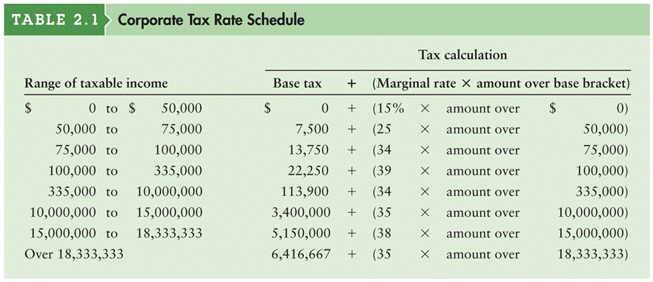

A firm’s marginal tax rate represents the rate at which additional income is taxed.

The average tax rate is the firm’s taxes divided by taxable income.
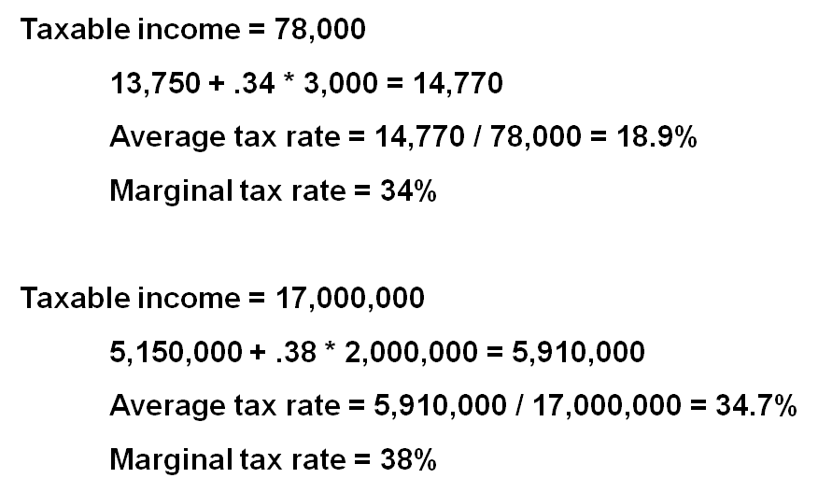

Interest and Dividend Income

For corporations only, 70% of all dividend income received from an investment in the stock of another corporation in which the firm has less than 20% ownership is excluded from taxation.

This exclusion moderates the effect of double taxation, which occurs when after-tax corporate earnings are distributed as cash dividends to stockholders, who then must pay personal taxes on the dividend amount.

Unlike dividend income, all interest income received is fully taxed.

