Chapter 3 Statements and Ratios

The Stockholders’ Report

Generally accepted accounting principles (GAAP) are the practice and procedure guidelines used to prepare and maintain financial records and reports;

The Sarbanes-Oxley Act of 2002, passed to eliminate the many disclosure and conflict of interest problems of corporations

More Countries Adopt International Financial Reporting Standards

International Financial Reporting Standards (IFRS) are established by the International Accounting Standards Board (IASB).

Focus on Ethics

Take Earnings Reports at Face Value

Near the end of each quarter, many companies unveil their quarterly performance.

Firms that beat analyst estimates often see their share prices jump, while those that miss estimates by even a small amount, tend to suffer price declines.

The practice of manipulating earnings in order to mislead investors is known as earnings management.

Why might financial managers be tempted to manage earnings?

Is it unethical for managers to manage earnings if they disclose their activities to investors?

The Income Statement

The income statement provides a financial summary of a company’s operating results during a specified period.

Although they are prepared quarterly for reporting purposes, they are generally computed monthly by management and quarterly for tax purposes.

Concentrate on control issue

Gross profit – control expenses of production

Operating profit – control of the expenses of “running” the company

Net income – remaining profits after all expenses pai

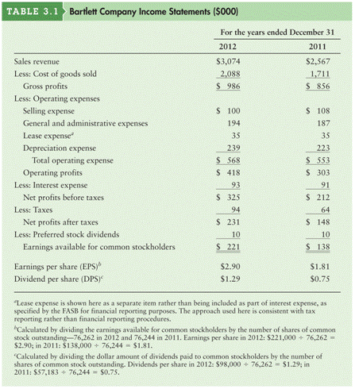
Personal Finance Example
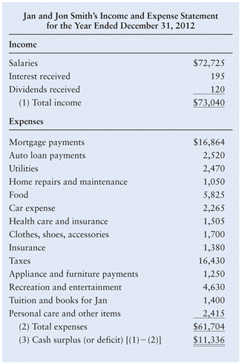

The Balance Sheet

The balance sheet presents a summary of a firm’s financial position at a given point in time.

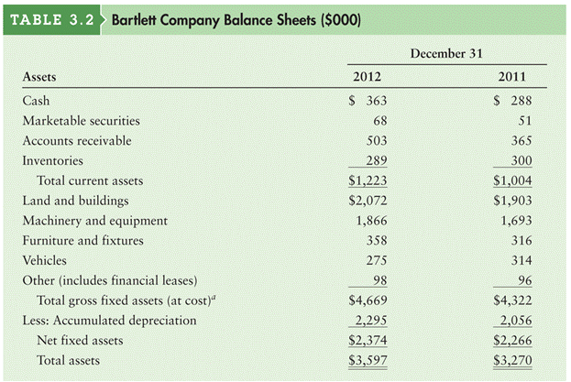
The statement balances the firm’s assets (what it owns) against its financing, which can be either debt (what it owes) or equity (what was provided by owners).

Represents the assets that management has purchased and uses to achieve it’s mission and goals.

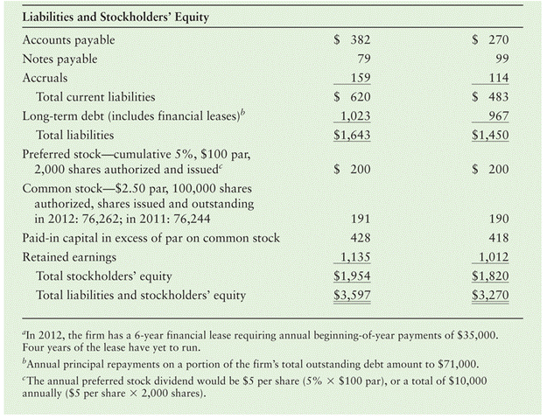

Represents the sources of financing used by management to purchase the assets of the firm.

Personal Finance
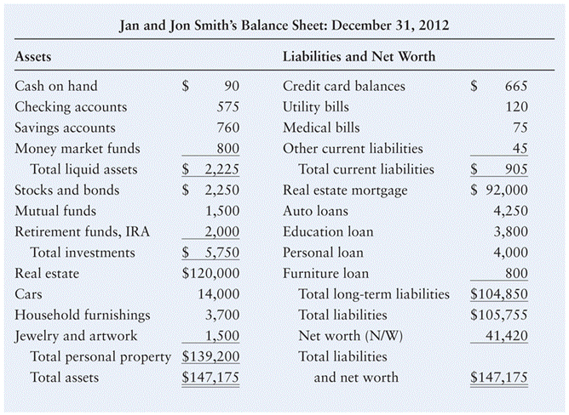

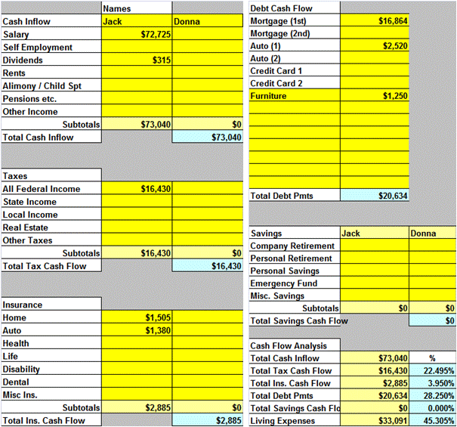
Personal Finance: Cash

Worksheet: Cash Management and Budget

This part of the worksheet is used to identify major levels of revenue and expenditure.

Debts include only loans, not utilities etc.

Individual personal expenses are considered in the next slide.

In this application, Living Expenses identifies remaining cash for other monthly expenses.

Breakdown into specific areas of spending

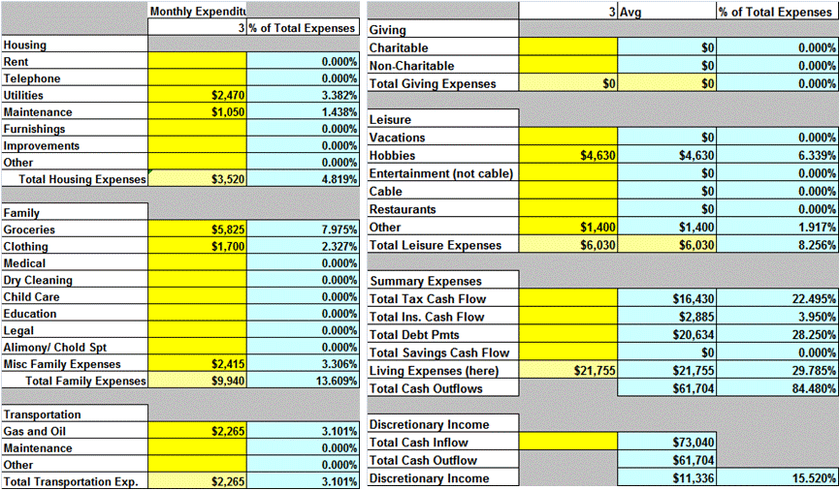
Discretionary Spending

after all revenues and expenses are accounted for this is the amount that should be left in the checkbook at the end.

What should you do with a surplus (+)?; a deficit (-)?

Personal Finance: Net Worth

Balance sheet looks very similar to a corporate balance sheet.

Net worth = Total Assets – Total Liabilities

If you retired and sold everything you owned and paid off everyone you owed; this is what you would have to live off the rest of your life.

When we are young this number is frequently negative. Especially if you have a student loan.

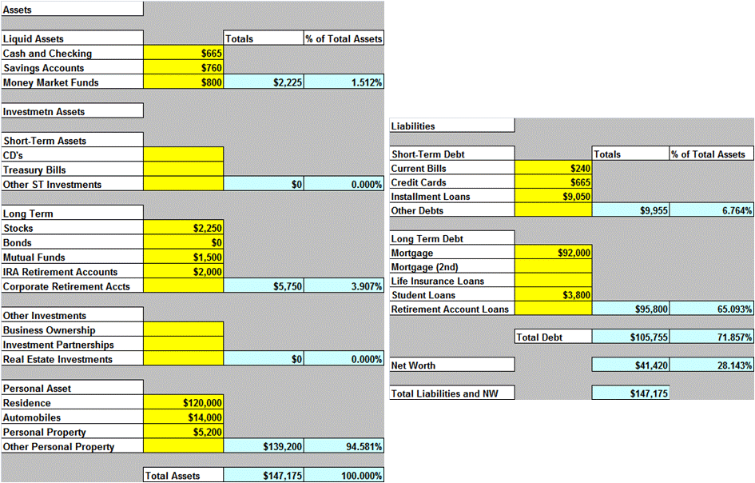
Why?

worksheet Personal Finance go to Cash Management area.

Statement of Retained Earnings

The statement of retained earnings reconciles the net income earned during a given year, and any cash dividends paid, with the change in retained earnings between the start and the end of that year.

Statement of Cash Flows

The statement of cash flows provides a summary of the firm’s operating, investment, and financing cash flows and reconciles them with changes in its cash and marketable securities during the period.

This statement not only provides insight into a company’s investment, financing and operating activities, but also ties together the income statement and previous and current balance sheets.
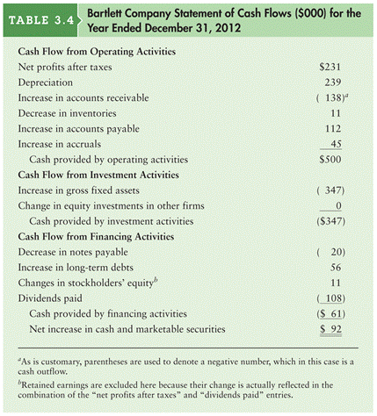

Chapter 3 Group Assignment (82 points)

(use financial analysis workbook / financial ratios)
Using the data from problem 3.23 in the text
Calculate DPS and EPS using this number (2 pts)
EPS =
DPS =

Input data into the financial analysis input section.
1) Create a table with the industry median ratio in column 2and the company’s ratio in column 3. (30 pts)

Ratio | 2011 | 2012 | Industry
CR
QR
DR
TIE
GPM
NPM
ROA
ROE

2) Define these types of ratios. In general, how is the company performing with each category?
(25 points)

Liquidity

Leverage

Profitability

3) Provide a brief description of the firm’s position relative to the industry. (25 pts)

Chapter 3 Web exercises (40)

Go to www.reuters.com/finance/stocks to obtain financial ratios
Stocks / input ticker symbol / ratios on the left
  - Liquidity (10)
    - Current and quick ratio
 | Industry | Company | Sector
CR
QR

What can you say about your company’s liquidity compared to the industry and sector?

  - Asset Mgt Ratios (10)
    - DSO = 365/ Rec turnover
    - DCI = 365 / Inv turnover
 | Industry | Company | Sector
DSO
DCI
How is your company handling accounts receivable and inventory compared to the industry and the sector?

  - Profitability (10)
    - GPM, OPM, NPM
 | Industry | Company | Sector
GPM
OPM
NPM

What can you tell me about your company’s profitability relative to the industry and the sector?

  - Leverage ratios (10)
    - LT Debt to Equity , TIE (interest coverage)

 | Industry | Company | Sector
Debt Equity (%)
TIE

Describe your company’s level of debt relative to the industry and the sector.

